

**DEPARTMENT OF INFORMATION TECHNOLOGY**

Course Code & Name : 101009IT422S, OPERATING SYSTEM LAB(Unix)

Regulations : 2021- Autonomous

Semester : S5

Programme : Computer Science and Business Systems

Prepared by : Mr. Mathews Abraham

RAJAGIRI SCHOOL OF ENGINEERING AND TECHNOLOGY (AUTONOMOUS)

Rajagiri Valley, Kakkanad, Kochi 682 039 Kerala INDIA

Tel: +91 484 2660999

**INSTRUCTIONS TO STUDENTS**

1. Students should report to the concerned labs 5 min prior to the given timetable.

2. All the students are supposed to enter the lab with the record.

3. All the students should sit according to their allotted seats given by the respective lab in charge.

4. Do not change the terminal on which you are working.

5. All the students are expected to get at least the algorithm of the program/concept to be implemented.

6. Final experiment signature should be given by the corresponding allotted faculty and they will enter the marks in the sheet given.

7. No student will be allowed to write the model exam without completing the fair record.

8. The fair record must be certified by the coordinator/lab-in-charge before the model exam at the last page of experiments, index page, and certificate page.

9. Strictly observe the instructions given by the teacher/Lab Instructor.

10. When the experiment is completed, students should shut down the computers before leaving the lab.

11. Any damage to the lab computers will be viewed seriously.

12. Students should not leave the lab without the concerned faculty’s permission.

13.Do not disturb machine Hardware / Software Setup.

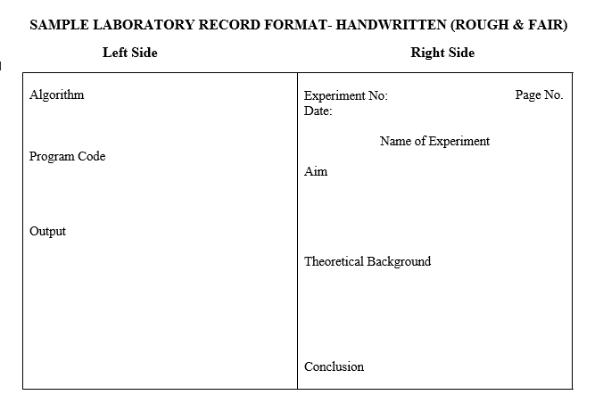

## PROCEDURE FOR EVALUATION

Mark distribution

|  |  |  |  |
| --- | --- | --- | --- |
| Total Marks | CIE | ESE | ESE Duration |
| 150 | 75 | 75 | 3 hours |

* Continuous Internal Evaluation Pattern:
* Attendance : 15marks
* Continuous Assessment : 30 marks
* Internal Test (Immediately before the second series test): 30 marks

**Experiment List**

1. Implement fork, exec, getpid, exit, wait, close system calls.
2. Unix commands (files directory, data manipulation, network communication, shell programming and vi editor).
3. Implement FCFS (Non-preemptive) scheduling algorithm and compute average waiting time and average turn-around time.

|  |  |  |
| --- | --- | --- |
| Process ID | Arrival Time(AT) | Burst Time(BT) |
| P0 | 0 | 2 |
| P1 | 1 | 6 |
| P2 | 2 | 4 |
| P3 | 3 | 9 |
| P4 | 6 | 12 |

1. Implement SJF (Non-preemptive) scheduling algorithm and compute average waiting time and average turn-around time.

Test Case 1

|  |  |  |
| --- | --- | --- |
| Process ID | Arrival Time(AT) | Burst Time(BT) |
| P0 | 1 | 7 |
| P1 | 3 | 3 |
| P2 | 6 | 2 |
| P3 | 7 | 10 |
| P4 | 9 | 8 |

Test Case 2

|  |  |  |
| --- | --- | --- |
| Process ID | Arrival Time(AT) | Burst Time(BT) |
| P0 | 0 | 3 |
| P1 | 2 | 6 |
| P2 | 4 | 4 |
| P3 | 6 | 5 |
| P4 | 8 | 2 |

1. Implement Priority Scheduling (Non-preemptive) scheduling algorithm and compute average waiting time and average turn-around time.

|  |  |  |  |
| --- | --- | --- | --- |
| Process ID | Arrival Time(AT) | Priority | Burst Time(BT) |
| P0 | 0 | 5 | 9 |
| P1 | 1 | 3 | 4 |
| P2 | 2 | 1 | 5 |
| P3 | 3 | 2 | 7 |
| P4 | 4 | 4 | 3 |

|  |  |  |  |
| --- | --- | --- | --- |
| Process ID | Arrival Time(AT) | Priority | Burst Time(BT) |
| P1 | 0 | 2 | 3 |
| P2 | 2 | 6 | 5 |
| P3 | 1 | 3 | 4 |
| P4 | 4 | 5 | 2 |
| P5 | 6 | 7 | 9 |
| P6 | 5 | 4 | 4 |
| P7 | 7 | 10 | 10 |

6. Implement Round Robin scheduling algorithm and compute average waiting time and average turn- around time. (time Quantum=2 ms).

|  |  |  |
| --- | --- | --- |
| Process ID | Arrival Time(AT) | Burst Time(BT) |
| P0 | 0 | 4 |
| P1 | 1 | 5 |
| P2 | 2 | 2 |
| P3 | 3 | 1 |
| P4 | 4 | 6 |
| P5 | 6 | 3 |

7. Implementation of IPC communication using Pipes,

8. Implementation of IPC communication using message queue

9. Implementation of IPC communication shared memory.

10. Implementation memory management scheme using first fit, Best fit, Worst fit .

Input: Memory size: 100kb,500kb, 200kb, 300kb, 600kb

Process size: 212kb, 417kb, 112 kb,426 kb

11.Consider the following snapshot of a system with five processes P0, P1, P2, P3, P4 and three resources A,B,C

i. What are the contents of need matrix?

ii. Find if the system is in safe state? If it is, find the safe sequence.

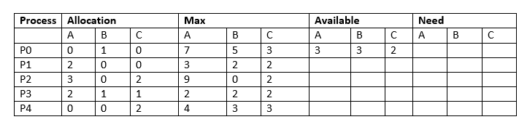

12. Implementation of Disk Scheduling Algorithms

Qn1.

A Disk contain 200 Tracks(0-199) Request queue contain track no: 82,170,43,

140, 24, 16,190 respectively. Current position of R/W head =50 calculate total number of track movement by R/W head using following algorithms.

a. FCFS

b. SSTF

c. SCAN

d. C.SCAN

.